Greetings Special Schools and Programs Members!
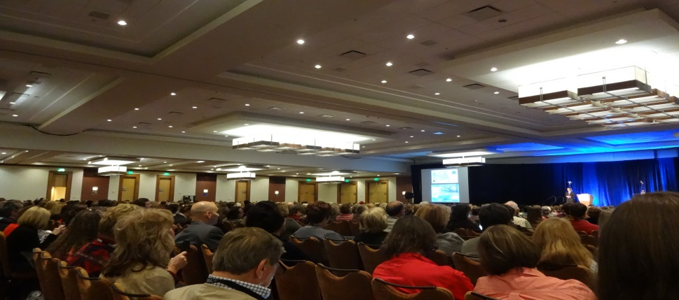
The 60th NAGC Convention in Indianapolis was grand! There were many varied and unusual sessions to choose from with great keynote speakers. The opening general session was “The Six Edges of Education Innovation” with Dr. Milton Chen and was packed with educators from around the world.
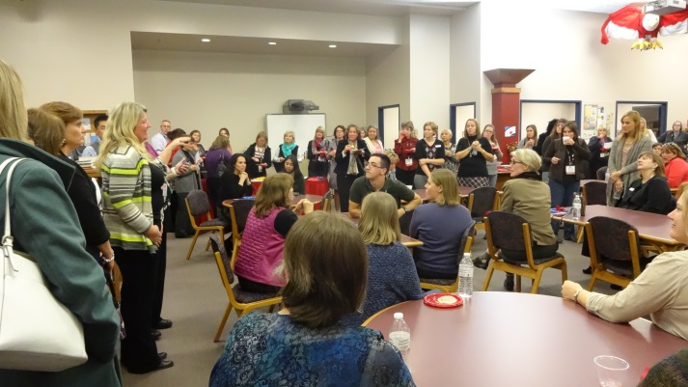
Special Schools and Programs along with Early Childhood and Middle Grades sponsored an evening event at Sycamore School. Sycamore School is a school devoted to gifted and talented students pre-k through 8th grade. We toured the school, viewed students’ work and met with colleagues new and old. It was a great event devoted to gifted education! Thank you Sycamore School for hosting this event!
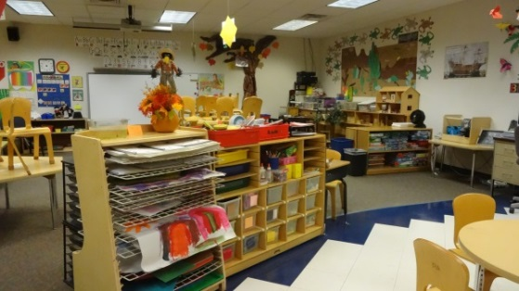
Proposals for NACG 2014 Convention
Baltimore, Maryland
November 13-17, 2014

The proposal site for 2014 is now open. Please submit your proposals by February 3, 2014. If you would like to be on the Program Committee contact Elizabeth Daniels at liz-daniels@utulsa.edu Program Committee members will review proposals for the 2014 convention. This is your chance to help select sessions for next year’s convention. Thanks to those who signed up to be a part of this exciting committee at Sycamore School and at the Special Schools and Programs Network meeting at the convention.
If you would like to become more involved with our network please contact Carol Carter at carol-carter@utulsa.edu
Volunteers are needed not only to read proposals but to help with our newsletter, memberships, and to run for co-chair in 2014.
Happy New Year!
Carol Carter

